Task 19 - Setup minikube at your local and explore creating namespaces (Go through official documentation)

Minikube can be setup in an EC2 instance with instance type as t2.medium

So create a new EC2 with instance type as t2.medium

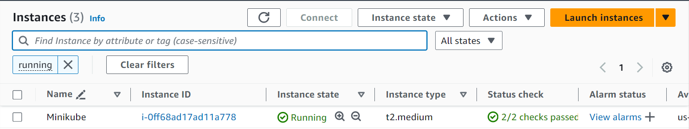

Now execute the following command in the EC2 machine to install Minikube,

$curl -LO https://storage.googleapis.com/minikube/releases/latest/minikube-linux-amd64

$sudo install minikube-linux-amd64 /usr/local/bin/minikube && rm minikube-linux-amd64

After installing the Minikube, install Docker in the EC2 instance by,

$sudo apt update

$sudo apt install docker.io

After installing Docker, also install the Kubectl by,

$curl -o kubectl https://amazon-eks.s3.us-west-2.amazonaws.com/1.19.6/2021-01-05/bin/linux/amd64/kubectl

$chmod +x ./kubectl

$sudo mv ./kubectl /usr/local/bin

$kubectl version --short –client

After this run the following commands,

$sudo chmod 777 /var/run/docker.sock

$minikube start --driver=docker

After all the installation, now we are going to create namespace,

Use the following command for creating namespaces,

$kubectl create namspaces

After creating the namespaces, get the list of namespaces available,

$kubectl get ns

